**PEMIKIRAN KRITIS DAN KREATIF**

**BIPW 3112**

**SEM 2 2021/2022**

**PROJEK IDEA INOVASI SOSIAL**

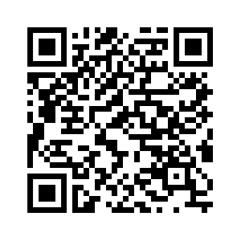

URL INOVASI SOSIAL 1

<https://vulcanpost.com/562701/social-entrepreneurship-malaysia/>

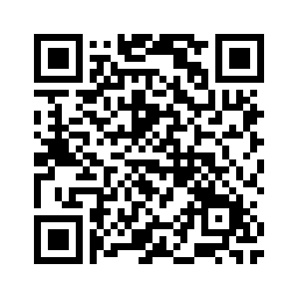

URL INOVASI SOSIAL 2



URL HATI.MY



BIJI BIJI



SILENT TEDDY

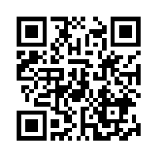

SKOLAFUND



REFUGEE FOR REFUGEES



PROJECT PAPLET



GREEN YARDS



MENSTRUATION MAN

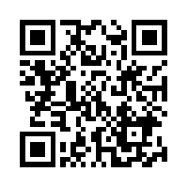

TOMS I41